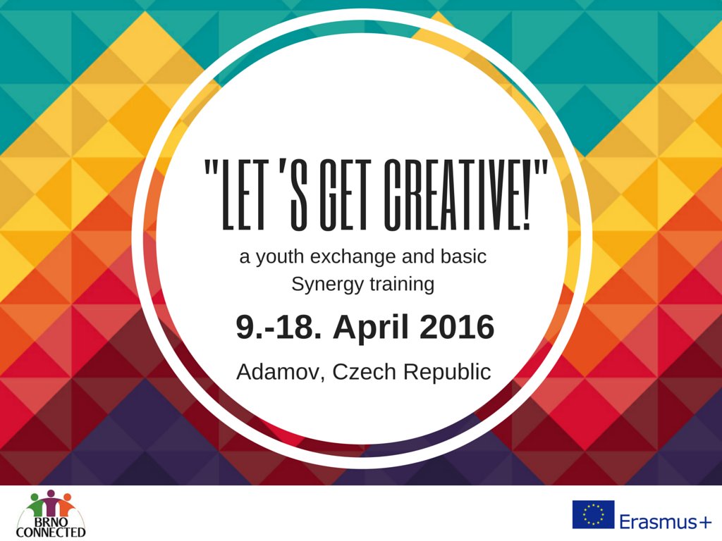

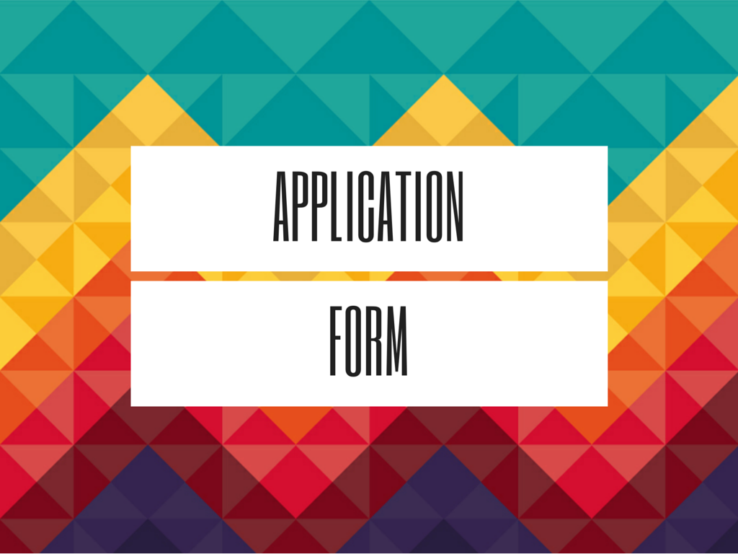

Personal information

First name:
Last name:
Name you want be called during the training:
Gender (F/M)
Date of birth:
Your age at the start of the exchange:
Address:

Zip code:
City:
Country:
E-mail address:
Phone number:
Contact person in case of emergency:

Name:
Last name:
Address:
Phone number:
Relation to you:
Your occupation or profession:

What is your level of English?
(excellent, good, medium, basic):

Do you need translation?

How did you find out about this training?

Please indicate if you face following conditions:
Are you unemployed?  (it doesn´t count if you are a student) | YES/NO
Did/do you have any educational problems (e.g. dropouts) | YES (please describe)/NO
Do you belong to a minority? | YES (please describe)/NO
Are you coming from an incomplete family? | YES/NO
Are you living in a conflict country or region? | YES (please describe)/NO
Do you face geographical obstacles (e.g. living isolated)? | YES (please describe)/NO
Motivation

How does the theme of the project relate to your life?
(min. 50 words)

What do you want to learn in this exchange concerning your own development?
(min. 50 words)
What is the situation of employability of young people in your country?

How are you being creative in your life?

How do you plan to use what you learn in training when you go back home?
(min. 50 words)

Health condition

What is your present health status?

Do you have any disabilities? (mental/physical)? Please describe your condition

Do you have any allergies? If yes, please specify

Do you have a special diet?
(if yes, please mention what type of special diet (vegetarian, allergies, etc.)
Do you take any medication? If yes, please specify (what, how often, what for)
Other remarks or questions:

I hereby declare that all the above information are true and correct to the best of my knowledge.
By submitting this application I, the undersigned, confirm that I have read and understood the Information
Letter and the conditions of reimbursement of the “Let´s Get Creative!” project and I know and accept the conditions of participation.

Date__________ Place_______________ Signature________________________

If you are selected for the project you will receive a confirmation letter with more details about your arrival and participation. If you have received this letter, only then you can start arranging your traveling.

All the information gathered in this form will be kept strictly confidential and only for the purposes of the project.

